A simple Touchscreen Controller (Windows) for VMIX.
Single EXE file, 350kb. You can run it from everywhere, no installation needed. No extras, only PGM, PREV and AUX BUS, max. 10 Inputs. The Panel scales according to the number of inputs. You can start/stop all 3 streams independent, start/stop recording and play/pause the active video on the output.
thats all.
No CG function, this can be done on the VMIX server itself or better with the Univeral Title Controller from the vMix Forum.
FREE Universal-Title-Controller
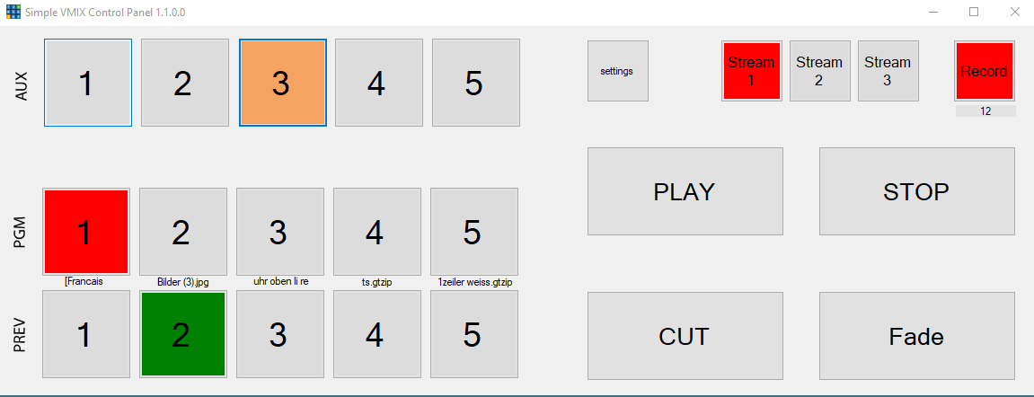
Visual Basic Source download HERE
Executable HERE
Since my small programs are not digitally signed, this warning appears the first time you start them.


