Larix Code Generator
This application generates links and QR codes for the client side using the APP “LARIX Broadcaster”. It is a single EXE file, for Windows only.
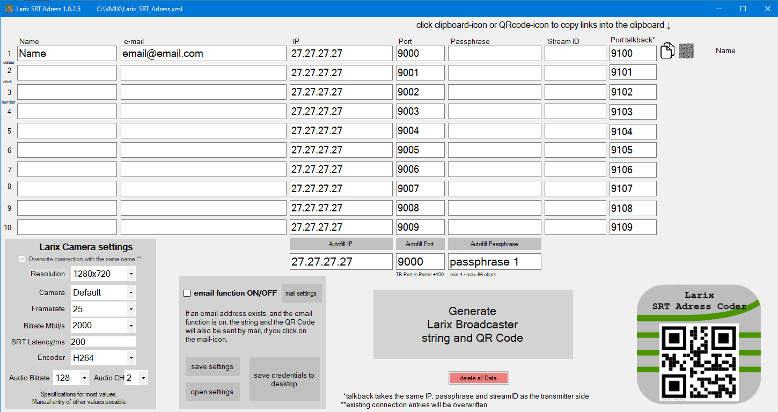
Download single EXE file
At startup the Windows 10 warning appears:


