Tennis24

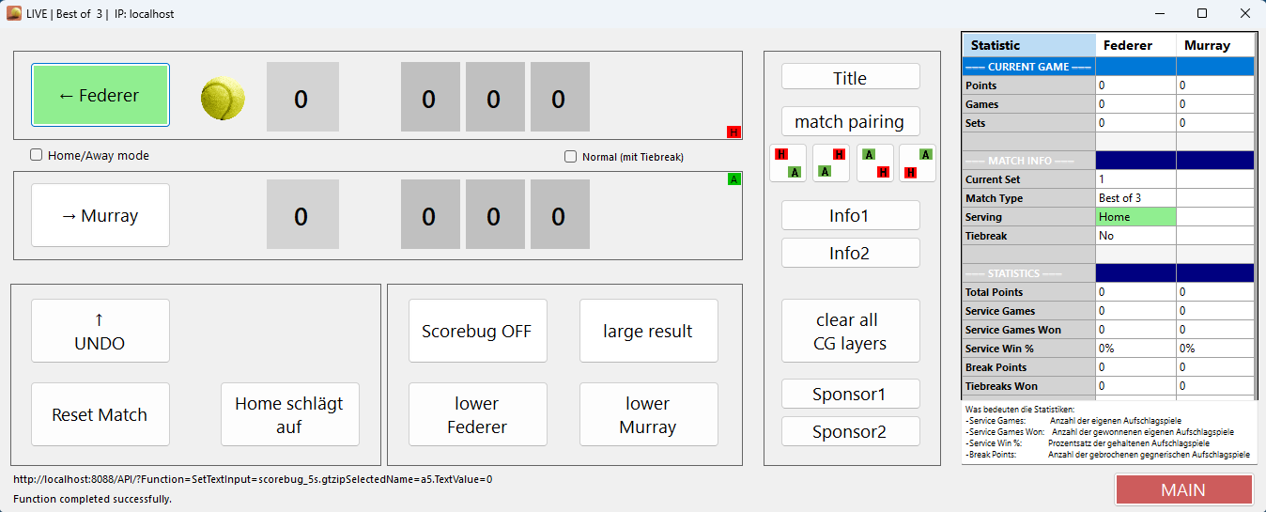
Tennis24 is a simple Windows tennis client for displaying points in a stream.
Ideally, it runs on a separate PC and then sends the data over the network to the vMix PC.
The graphic templates are not subject to copyright and may be used freely.
The programme saves the player names and some settings in the directory C:\vmix\tennis\data
All GT titles are in the directory C:\vmix\tennis\titles
(Please note that if you change GT titles, the field names must remain the same)
Graphical templates are located in the directory C:\VMIX\tennis\graphical_templates
The flags used by the programme are located in C:\VMIX\tennis\flags
The download includes the Tennis directory with all subdirectories.
Copy this to the directory c:\vMix
It should then look like this:
C:\VMIX>
└──tennis
├───data
├───flags
├───graphical_templates
├───setup
│ └───Application Files
│ └───Tennis24_1_0_0_7
├───titles
└───vMix_project
In the Setup directory, you will find the setup programme for the client, and in vMix_project, you will find the vMix project, which then loads all titles.
Download HERE

