vMix Script Remote
This small, Windows-PC only, software starts fixed vMix scripts. The script names cannot be changed. Each button calls up a script when pressed and calls up another script when released. With the introduction of Streamdeck XL-panels and Bitfocus Companion, this software is obsolete.
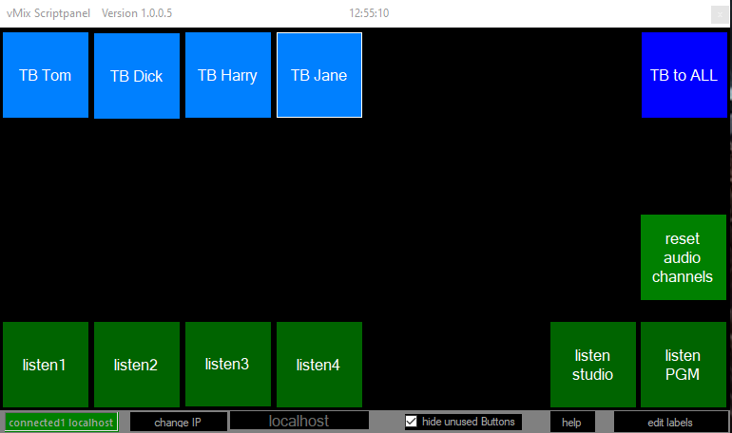
The scripts must exist in vMix, This panel does not create any scripts. It recalls them only in vMix. The program is a single EXE file and needs no installation. If you run it on the same computer as the vMix program, set the IP to “localhost”. (Without quotation marks…) If the program is running on another computer in the same network, set IP to the IP of the vMix computer. It also runs over WLAN and needs very little traffic.If you run it on the same computer as the vMix program, set the IP to “localhost”. Please report any errors. My system works as described, further applications are not tested
ATTENTION. Use only lowercase for the scriptnames.
Button1, press, calls script1down Button1, release, calls script1up … Button32, press, calls script32down Button32, release, calls script32up
Button 25 – Button 32 have holding function
With this panel, intercom and monitoring, or any script-driven vMix-thing can be easily called.
Download Program and Manuals Here
Since my small programs are not digitally signed, this warning appears the first time you start them.


