soccerclock (tiny little soccer clock)
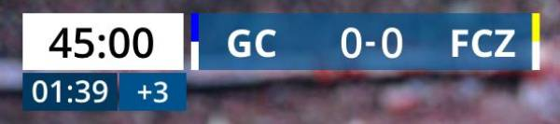\
Soccerclock is a Windows program, a football client for displaying time and scores in a stream and for LED display on the field. The idea originated from a small youth football club that streams its games and has a small LED wall on the field where they wanted to display scores and advertisements. The program works with an older HP Office Windows laptop with USB2 and Intel HD Graphics 520, using the vMix Basic HD version for $60. (vMix and soccerclock run on the same computer).
The clock offers 2 options: it can either continue running after 45 minutes as 45:01, 45:02, etc., or split the display. In the split mode, the 45:00 on the time display remains fixed, and the extra time starts running in a separate field below. It is also possible to show the referee’s added time in another field. However, it is not common for the referee to share this information during school games.
Additionally, there are titles available for the start, half-time, and end of the match. Templates for the scorebug, public-display, and titles are included. Experienced vMix users can create or use their own templates, and title fields for most objects can be customized in the setup.
The program saves the field names of templates, team matchups, title names, etc. However, there is no club database. The club names are taken from the names of the club logos. A club logo must always be 500×500 pixels in .png format.
The directory for the logos is hardcoded and cannot be changed.
C:\vmix\soccerclock\logos
The naming convention is as follows:
ATTENTION: the long name (clubLong) must NOT contain a hyphen!
clubShort-hyphen-clubLong.png
FCZ - FC Zürich.png
GC - Grasshoppers Club Zürich.png
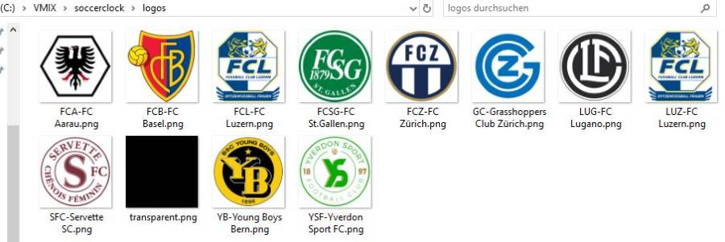
If a logo is missing, no output can be displayed. The program requires two valid logos. In the logos directory, there is a transparent logo available. If necessary, this can be copied as a club logo.

soccerclock-Client
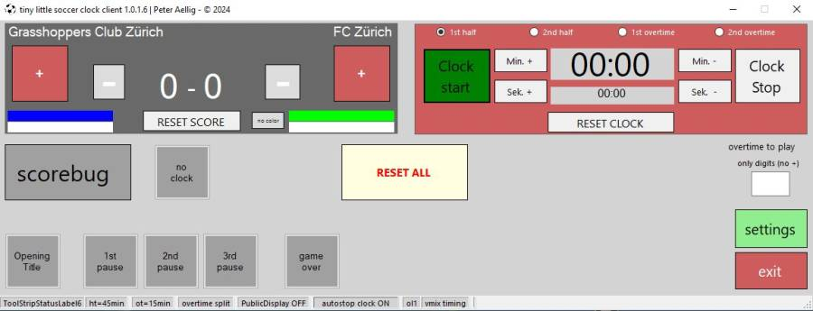

soccerclock-Diagram
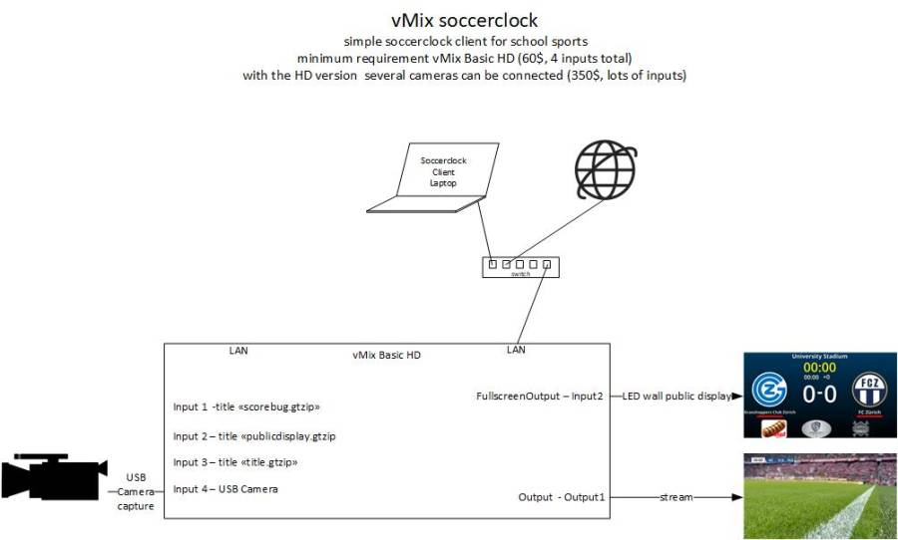

Soccerclock Output stream
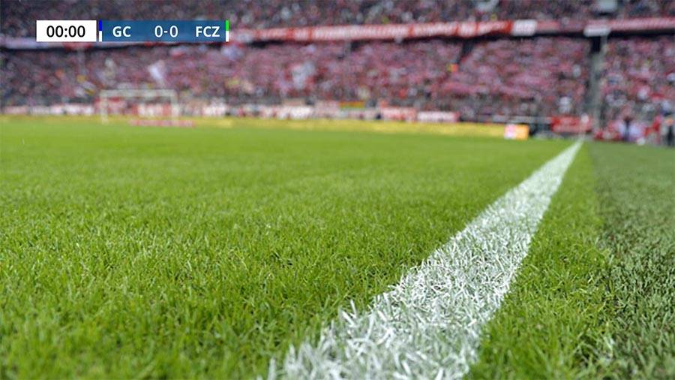

Soccerclock Output stream, time split
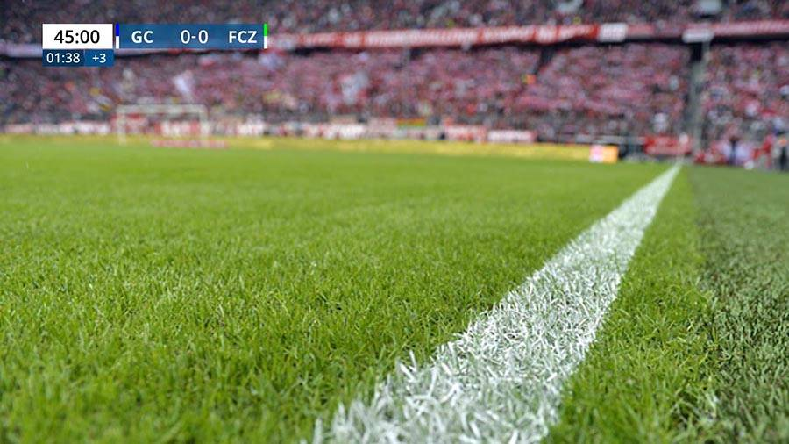

Soccerclock Game Titles, Output stream
Titles for before the game, halftime, and the end of the game can be displayed:
 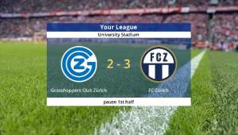 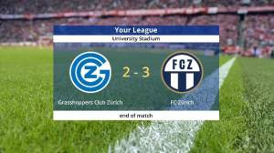

Soccerclock Output Public LED Wall
This is a full-screen display that needs to be output via the HDMI port from the laptop to the LED wall.
The advertisement logos in the GT-title publicdisplay.gtzip need to be changed manually and are saved in the title file publicdisplay.gtzip. This only needs to be done once if one or more advertisement logos are changed.

Change Advertisement
Right-click on the input, select Title Editor, Images, and adjust Advertising_L/M/R.Source with Browse, and THEN SAVE THE PROJECT!!!!
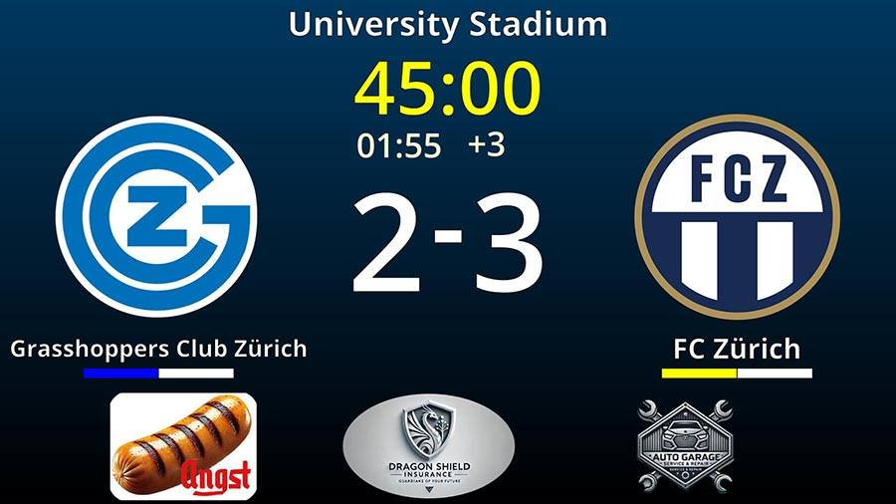

Soccerclock settings
In the setup section, various things can be changed, including the storage location of the three titles: 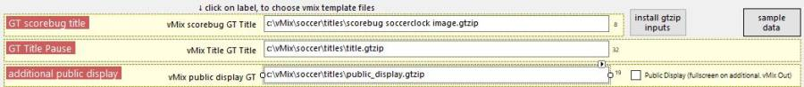
Additionally, the names of various fields in the template can be changed. This is only necessary if you want to use other or existing gtzip templates or give the fields different names. (only for experienced GT-Title users)
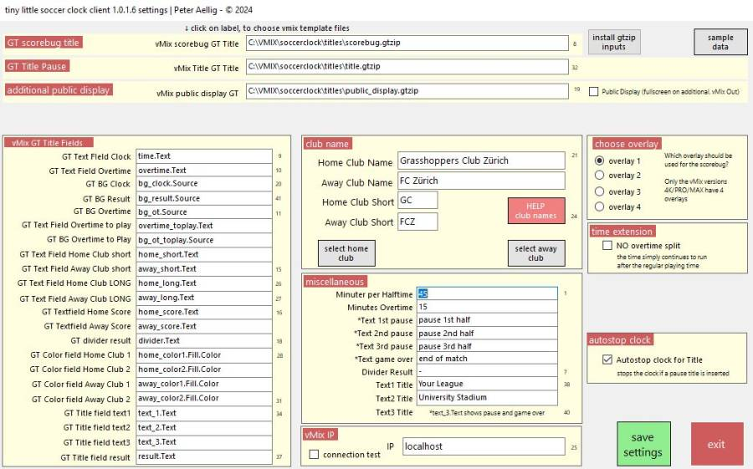
Simply download and try it out.

Setup

Setup Order
- Start vMix with an empty project of your choice
- Install soccerclock software initially on the same computer as vMix
- Ignore the message that the software is not digitally signed and press Install.
- Start soccerclock. A message will appear stating that the directory c:\vmix\soccerclock does not exist and no settings file is available. Press OK, and all necessary directories will be created and populated with sample data. Additionally, GT-title templates, club and advertisement logos, and the necessary fonts will be copied to their respective directories. The fonts are from Google and can be used without a license, even commercially. Please unzip the fonts and install them. *Nothing can go wrong here…

download
Download HERE
Unzip the file and start setup.exe.
Click Install and follow the setup order described above.
Since my applications are not digitally signed, this screen will appear:


