HTML Button Panel
These are three HTML code files, which can be saved anywhere as Page1.html, Page2.html and Page3.html). The 3 files must be in the same directory.
The buttons and the vMix commands are stored in a text list within the code. There you edit your corresponding vMix functions and the resulting button text. There are maximum 60 buttons, the last 3 Buttons are always reserved for the 3 pages, PAGE1-3)
Only those buttons are displayed which have a function and a button name in the entry. These are entered in the code (Page1.html…) as follows:
{ command: "Function=ActiveInput&Input=1&Mix=0", label: "Applaus short" },
An empty button with the following line can be created:
{ command: " ", label: " " },
A maximum of 57 buttons are displayed, each with 10 buttons in a row. Further buttons in the entry are ignored.
The last 3 entries each call up Page1.html or Page2.html or Page3.html
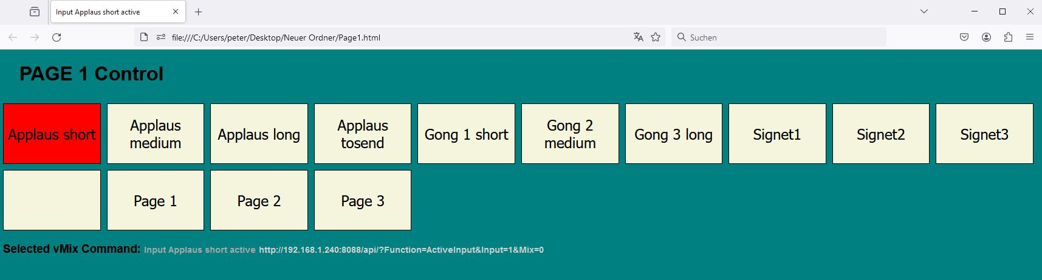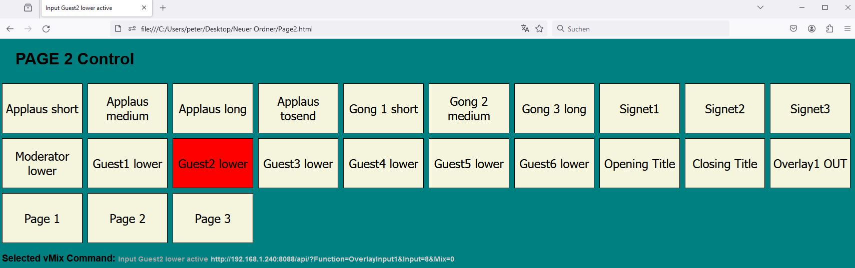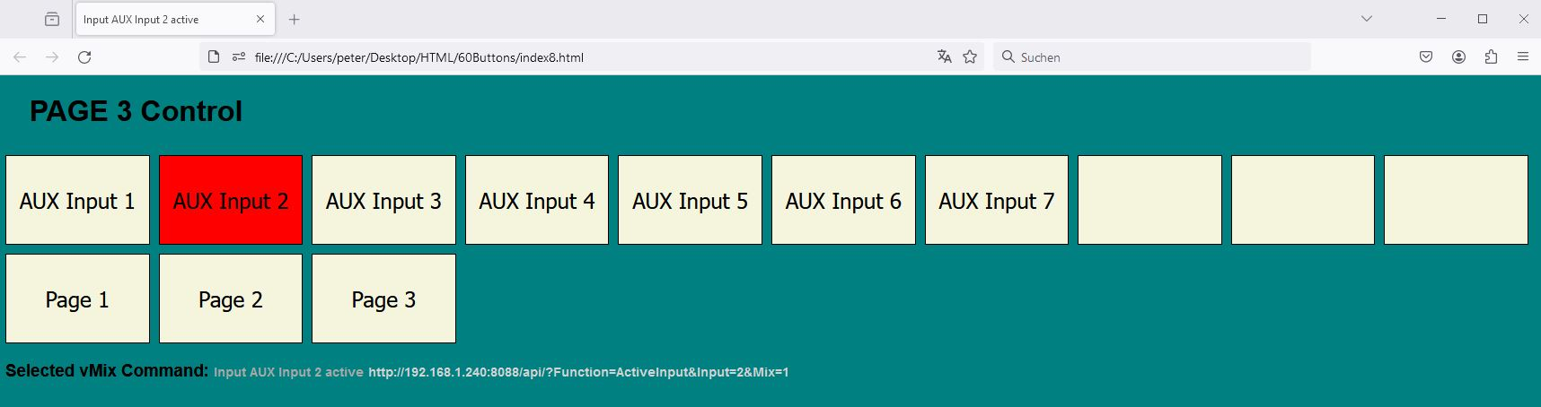
With a little experience in HTML code and vMix functions, you can easily adapt the panel to your needs.
It is important that the IP address of the vMix computer to be controlled is correct in the code. Several such instances can run in parallel or on different computers.
I have not found a way to display HTML code in this WIKI. Therefore the code comes as a ZIP document. I know this is not the best way in view of the virus plagues everywhere. This ZIP is also scanned during download. The ZIP contains Page1.html, Page2.html, Page3.html. The HTML files can be edited with any text editor.
Buttons and the associated text scale with the window size.
With HTML experience, you can also give the pages other names, call up more than 3 pages, etc.
Running on another computer, the buttons can also have other functions. The possibilities are almost limitless
60buttons.zip

