vMix API Schedule
This simple program can send time-controlled vMix API commands to vMix. Multiple commands can be sent at the same time.
If anyone would like to have the code to extend the program, please send an email to admin@tvcrew.ch
After the event, the OnOff field is colored green or the line is removed, depending on your choice.
The vMix functions are not checked for validity. If the command is recognized by vMix, vMix Function: function completed is displayed.
The IP must be set if the program is not running on the same computer as vMix. The IP is saved automatically.
The authorizations for receiving external commands must also be set in the vMix settings, Web controller.
The program is a single.exe file and does not require installation. A directory is created to save the data. (C:\VMIX\vmixapischedule) PLEASE NOTE:
The data is only saved when the “save schedule” button is pressed!
Download Hier
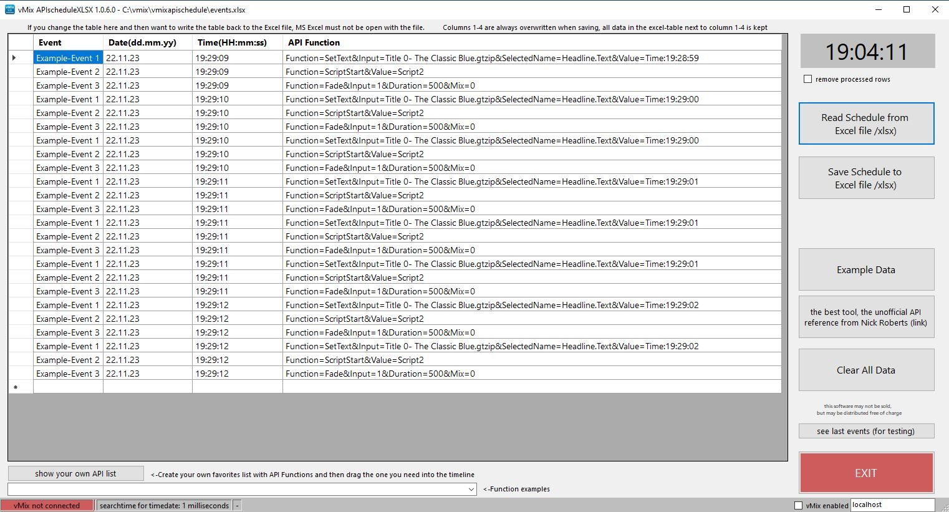
Da meine Programme nicht digital signiert sind, kommt beim ersten Mal starten eine Windows 10 Warnung. Click auf weitere Informationen, trotzdem ausführen.
Since my programs are not digitally signed, a Windows 10 warning appears the first time I start them. Click on further information, run anyway.

Das Programm ist kostenlos und darf weiter verteilt werden..

