Larix Code Generator (for Windows only)
This application generates links and QR-codes for the client side using the APP “LARIX Broadcaster”. The program is a single-EXE file and does not require installation. It creates the directory “C:\vMix\LarixSRTQR” to store your data.
If you have Larix Broadcaster installed, you can test capture the code, below on the image, with your phone camera and import the data to understand how it works.
ATTENTION: since the beginning of 2023 the Larix Broadcaster program is restricted without payment. If you still want unlimited use, you have to pay 10€/month or 20€/month (with NDI) for the subscription in the App Store.
Portnumbers and IP Adresses are only examples!
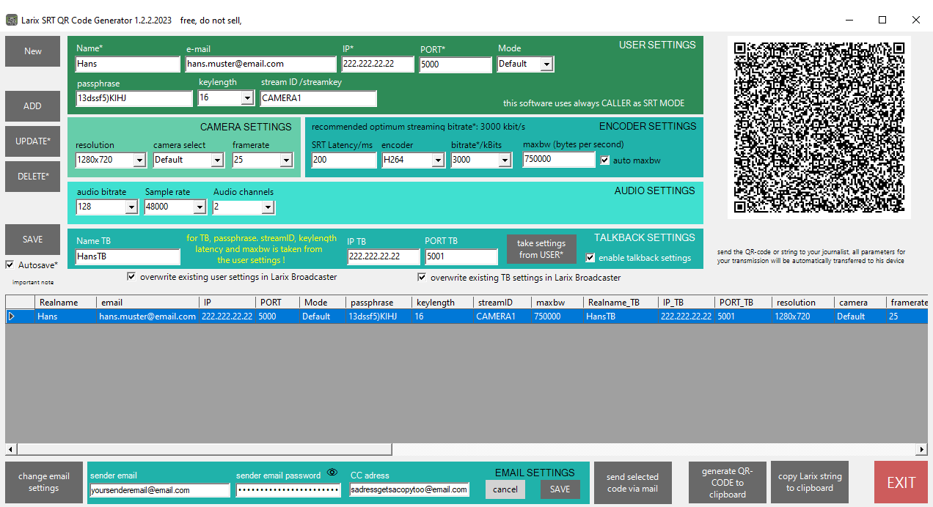
Download zipped EXE
Since my small programs are not digitally signed, this warning appears the first time you start them.

The program is free and may be redistributed..

