IDentify

Overview
Identify is a broadcast test pattern generator with text-to-speech functionality. The programme displays a test pattern with colour bars, a grey scale and a real-time clock. It features an internal test pattern, freely configurable text lines, a countdown, and a crawl, either with your own text or an RSS feed. Optionally, you can integrate your own logo. Alternatively, you can use your own HTML files – examples of these can be found in the download folder. The programme runs on Windows 10 or 11 (64-bit). It includes an integrated manual that also explains how to install additional languages. Although not all available languages are supported, the manual describes the most common ones that work.
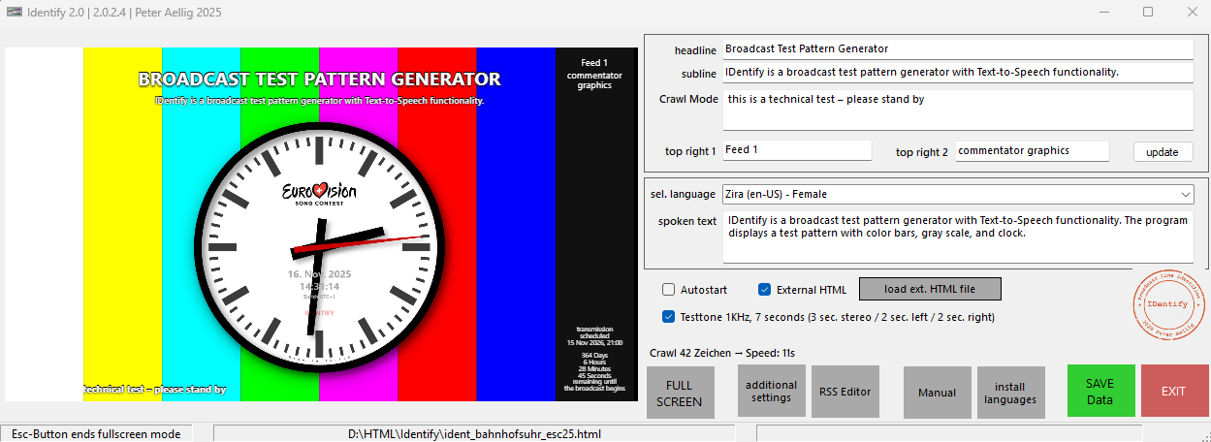
Download HERE
There are a few HTML examples in the download folder.
If you want to add your own logo to the internal test image, use a 1920×1080 transparent image that contains your logo in the desired position and size.
If you want to add your logo to the station clock, convert your logo into BASE64 code and insert it into the HTML code.

