Haivision PRO Code Generator (only for Windows)
This application generates links and QR codes for the client side, which use the APP “Haivision Pro”.
If you have Haivision Pro installed, you can capture the code at the bottom of the picture with your cell phone camera and import the data to understand how it works.
Haivision Pro streams SRT or plays SRT streams.
PLAY
If you have created or received a valid SRT link, all you have to do is hold the cell phone camera (not Haivision Pro QR code camera!) on the QR code, click the APP link and Haivision Pro will play the stream. No further settings are necessary.
STREAM
If you have created or received a valid SRT link, it is sufficient to hold the cell phone camera (not Haivision Pro QR code camera!) on the QR code, click on the APP link and the stream window of the APP will appear. Now click on Stream and you are online.
First and foremost, I wrote the program to easily pass on QR codes for the SRT Miniserver. But it also works with other SRT sources.
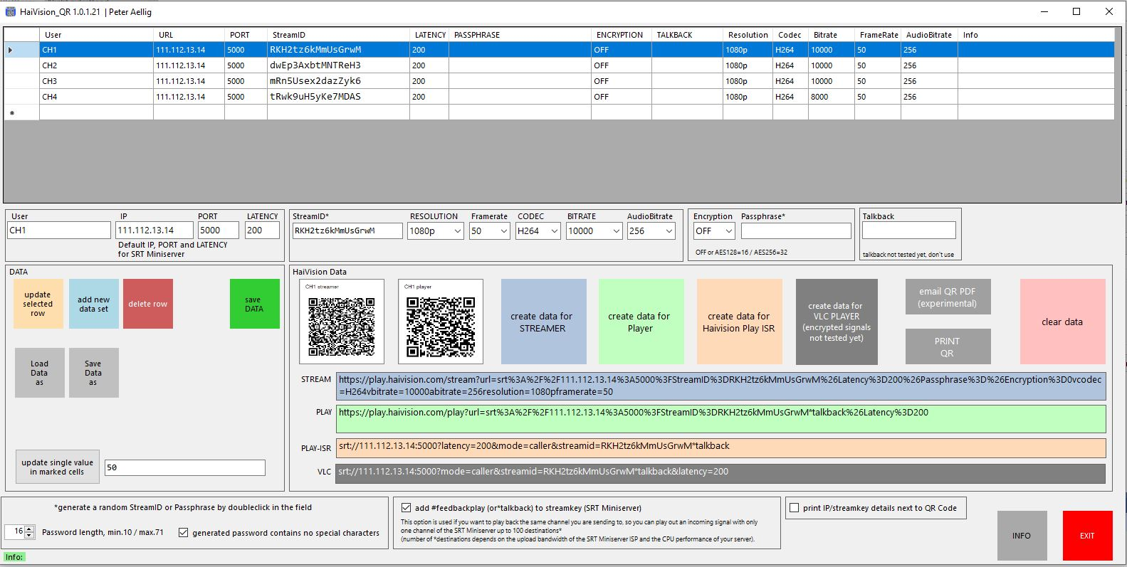
Port numbers and IP addresses are only examples!
Download here

