vMix Script Save
The scripts are stored either in the general „user.config“ or in a vmix preset. The scripts in user.config are available to all vMix presets, the scripts from a preset are „local“ and are only available to that project (preset).
Extracting a script from a preset is easy, it is located where you saved the preset. The presets have the extension .vmix.
Finding the user.config file is a bit difficult. It is located in the %appdata% directory, but not in the automatically opened Roaming, but in the Local directory .
In it there is a directory „StudioCoast_Pty_Ltd“.
In this directory there are two more directories, one of them starts with vMix64.exe and another long string, for me it looks like this
vMix64.exe_Url_5l40qvre1y15xxxxxxt1gelpnmwemdfj. This number is individual to each PC and Licence.
This Folder contains all vMix program versions ever installed as subdirectories.
23.0.0.57
…..
…..
24.0.0.71
The last directory with the highest number contains the user.config file with the general scripts.
C:\Users\yourPC\AppData\Local\StudioCoast_Pty_LtdvMix64.exe_Url_5l40qvre1y15xxxxxxt1gelpnmwemdfj\24.0.0.71
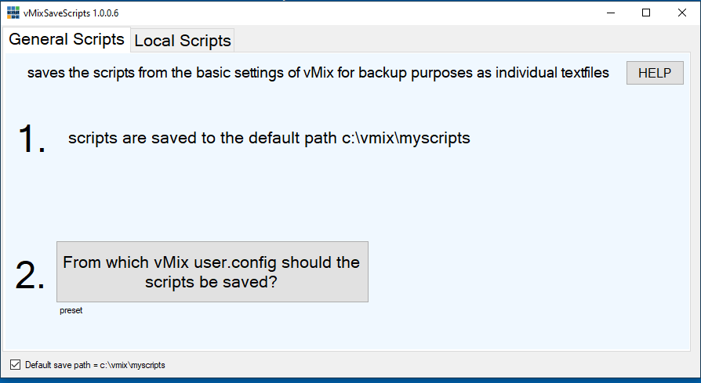
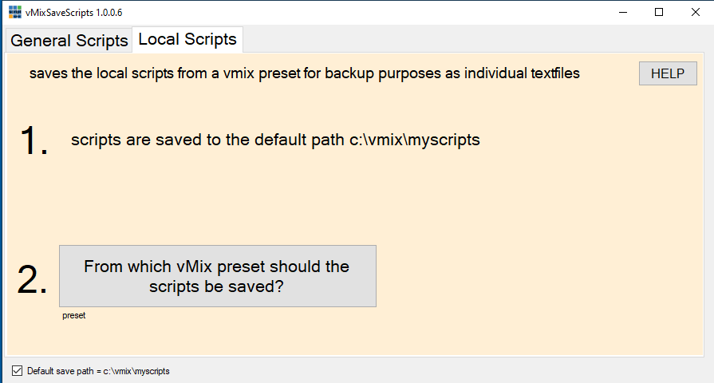
Download exe download HERE as EXE
Download zip download HERE as ZIP
Da meine Programme nicht digital signiert sind, kommt beim ersten Mal starten eine Windows 10 Warnung. Click auf weitere Informationen, trotzdem ausführen.


